A

PROJECT SYNOPSIS

ON

“Strings – An Artsy Social Networking Site”

Submitted to

Rashtrasant Tukdoji Maharaj Nagpur

University, Nagpur

In the Partial Fulfillment of

B. Com. Computer Application Final Year

**Submitted By**

Mr. Doshant Giradkar

**Under The Guidance of**

Prof. Shripad Dixit



G.S. College of Commerce, Wardha

2023-24

**Introduction:**

* In an era where every artist’s dream is to stand out, **Strings** emerges as the bridge between creators and their global audience. Whether you wield a stylus or a mouse, this digital gallery invites you to showcase your masterpieces, share your process, and find kindred spirits who resonate with your vision.
* Curate your digital gallery. Showcase your best work, from that mesmerizing digital landscape to the quirky pixel portrait. Each piece is a thread in your artistic journey on Strings.

**Objectives of the project: -**

* To allow artists to create profiles and share their artwork.
* To enable artists to connect with each other.
* To provide features for discovering and appreciating artwork.
* To build an engaging community for artists around the world.

**Project Category: -**

* **Full Stack Web Application:**

A Full Stack Web Application is an application which implements both **Backend, Frontend & Database**, And serves webpages to its users, as per the user’s request.

**Tools Platform/Languages to be used: -**

* **Front End:** HTML, CSS, JavaScript
* **Back End:** NodeJS, PostgreSQL

**Software Requirements: -**

* **Vscode:** Vscode is a lightweight but powerful code editor that runs on multiple operating systems including windows, linux and
* **Browser:** A browser is an application which is used to request web-urls and render the output to users.
* **NPM:** Node Package Manager is the command line tool, used to manage external libraries & dependencies in a NodeJS project.

**Hardware Requirements: -**

* **Processor:** Dual Core Processor
* **Ram:** 2 GB RAM Or More
* **Hard Disk:** 8 GB Of Free Space Or More

**Complete structure of the system:-**

* **Number of module and its description:**

1. **Login & Registration Module:** This module contains login & registration form, to allow users to login & register to the application.
2. **Upload Module:** This module contains a HTML POST from for upload. And the functionality to upload images with the title
3. **Like & Dislike Module:** This module handles the functionality of Like & Dislike.
4. **Delete Module:** Allows user to delete their own post, and administrator to delete other user’s posts.
5. **Content Module:** The content moudle adds the content to HTML document, before sending it over to users.

* **E-R Diagram: -**

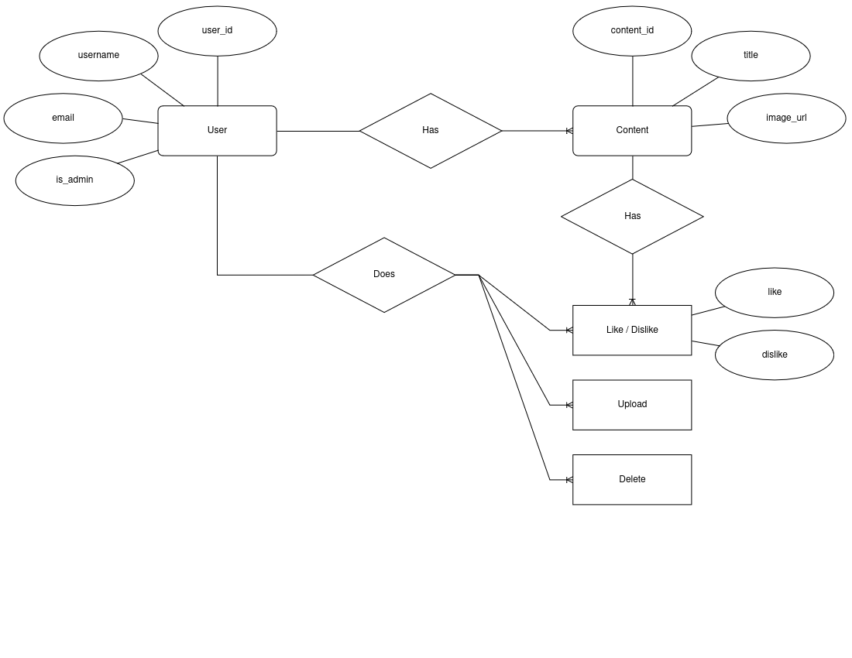

* **Modular Chart: -**
* **Data Structure or Tables**

1. **Users Table**

|  |  |  |
| --- | --- | --- |
| **Feild** | **Type** | **Description** |
| user_id | INTEGER | NOT NULL AUTO INCREMENT PRIMARY KEY |
| username | VARCHAR(50) | NOT NULL UNIQUE |
| email | VARCHAR(255) | NOT NULL UNIQUE |
| is_adm | BOOLEAN | NOT NULL |
| pass_hash | VARCHAR(255) | NOT NULL |

1. **Content Table**

|  |  |  |
| --- | --- | --- |
| **Feild** | **Type** | **Description** |
| content_id | BIGINT | NOT NULL AUTO INCREMENT PRIMARY KEY UNIQUE |
| user_id | INTEGER | NOT NULL FOREIGN KEY |
| title | VARCHAR(255) | NOT NULL |
| img | VARCHAR(255) | NOT NULL UNIQUE |

1. **Actions Table**

|  |  |  |
| --- | --- | --- |
| **Feild** | **Type** | **Description** |
| content_id | BIGINT | NOT NULL FOREIGN KEY |
| user_id | INTEGER | NOT NULL FOREIGN KEY |
| _like | BOOLEAN |  |
| _dislike | BOOLEAN |  |

**Submitted by**

*Mr. Doshant M. Giradkar*